Jordan Lesniak

Phy 492 Final Paper

4/21/2021

**Proton Decay**

**d2l1 Introduction**

I have decided to focus my final paper on the studies of proton decay, or otherwise known as proton radioactivity. I found proton decay particularly interesting because it is fairly a new topic of study in the scientific world in comparison to the other types of radioactive decays such as alpha or beta decay which have both been studied for more than a century each. I, as have many other people, thought since neutrons and electrons are able to decay into smaller pieces of matter, why have we not been able to observe this with the proton. In this paper I will dive into the history and some of the reasons scientists have not been able to measure proton decay yet.

**2 History**

The idea of proton decay can be attributed to Andrei Sakharov, who hypothesized the idea formally in 1967. Although there have been many studies and experiments into observing such a proton decay, there has yet to be a successful discovery. There is something similar to proton decay which is called positron emission that can be confused with proton decay. Positron emission has been fully observed, unlike proton decay, and this is when a proton interacts with other subatomic particles and becomes a neutron. This is not classified as pure proton decay since the proton is interacting with other particles. For proton decay to happen, a proton must decay into lighter subatomic particles on its own as a neutron would in neutron beta decay. This hypothetical proton decay process could look like a proton decaying into a neutral pion and a positron.

**3 Processes Behind Proton Decay**

When considering how proton decay would be possible, sensibly scientists have looked into how the other flavors of particle decay happen and looked at the underlying rules that must be followed for these processes to happen. In nuclear physics, for any type of decay to happen (alpha, beta, gamma), there must be conservation of charge, conservation of momentum, and the conservation of energy. Now when looking at proton decay, the problem is not that this type of decay would violate one of these laws. In fact there is nothing actually stopping this process since theoretically it is possible since there are lighter particles that retain the same charge as the proton.

Physically a proton is only slightly lighter than a neutron and has a positive charge. Since they have very similar weights, is proton decay not happening due to its positive charge? While this may be an interesting thought at first, there are still smaller particles like the quarks that compose the proton that could be theoretically decayed into, and still uphold the conservation of charge law. Since this is the case, why have we not observed proton decay yet? The answer to this may lay in the fact that the proton might just be what's called “intrinsically stable”. Basically, scientists now hypothesize that the proton is non-decayable. We have observed this “non-decayable” phenomena in other particles such as the electron, electron neutrino, and the photon. The reason these particles are non-decayable is because there are no lighter particles than the ones listed, that can also withhold the conservation of charge law in any form of decay possible. But this is not the case for the proton. In the coming sections we will further dive into the search for this mysterious proton decay and why this is even important to the scientific community.

Now, if we were to hypothesize that the process of proton decay was possible and it did occur in nature, we would need to come up with a blueprint for how exactly this decay would happen. We would have to work out all of the math and physics to make everything work behind the scenes, and not break any laws of physics. Now unlike the electron, electron neutrino, and the photon, a proton is theoretically possible and we do have the means (other subatomic particles) to make a theoretical prediction for how this decay would actually appear in nature. One way scientists have come up with for how this proton decay might happen is for a proton to decay into the three quarks that make up the proton. One of these quarks decays into a lepton, while the other two decay into an unstable meson, which then immediately decays into two gamma rays. Below is a simple picture model of how this decay process might look.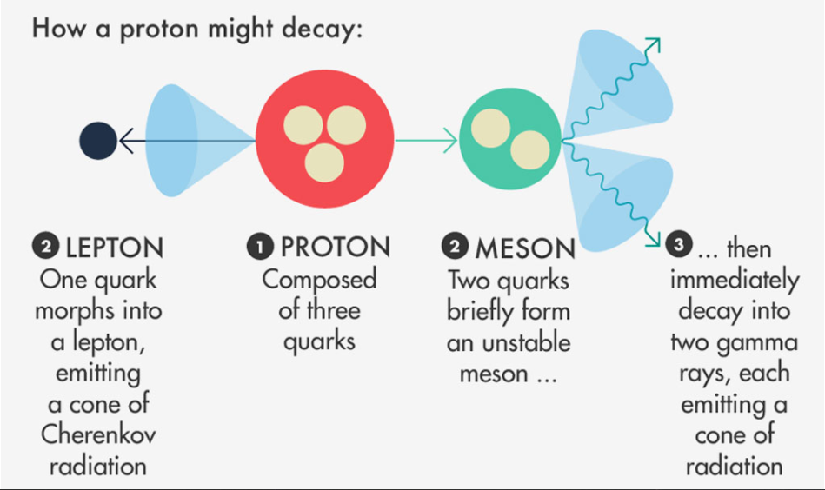

Now this model is just one theoretical prediction scientists have made of how a proton decay might look like. Another possibility is for a proton to decay into two gamma rays like before and a positron on the left side instead of a lepton.

**4 Importance of Proton Decay**

The search for proton decay has been a study in the field of nuclear physics ever since the 1970’s. This flavor of decay was one of the key predictions that could change our grand unified theories, or (GUTs). The grand unified theory, which was proposed in the 1970’s as well, predicted that the proton has a short enough lifetime so that experiments could be made to detect when their life comes to an end and they decay. The GUTs is the theory that the three of the four fundamental forces of the universe were once unified into one. These being the strong, weak, electromagnetic forces. Gravity was and still is left out of this GUT since we still do not have a reliable theory of gravity on the quantum level yet, for which we have for the other three forces.

If scientists were ever able to detect this renowned proton decay, it would be monumental to the evidence of a new GUTs, and would play an invaluable part in proving at the beginning of the big bang, there was ONE fundamental force that then split into the known forces we observe today. The problem with this, is that under the newest GUTs, finds that subatomic particles must live, on average, at least 16 billion trillion trillion years, or 1.6e34 years. This number is so insanely large that any chance of us being able to randomly observe a single proton decay is basically impossible *if* it is even possible. To put this number into perspective, the universe itself is only 1.4e10 years old. This means the proton's life on average is 10e24 years longer than the age of our universe that we live in. As you can see, we can not just wait around and hope a proton decay will just happen, we have to increase the odds of this. To do this all we need to do is get a lot of protons in a very secluded place and constantly observe them.

So how exactly is the proton decay process even relatively important to the GUTs and why does it even matter? Under the current taken theory of the standard model, the proton decay is not predicted. If proton decay is ever measured this would force scientists into considering new physics into the encryption of the universe we live in. The ultimate goal of the scientists that are performing cutting edge research on a new GUT is to bring together all of the phenomena of our world into one unified force. One way they are trying to make headway on this new GUT is to observe the disintegration of the proton.

**5 Experiments**

One of the most famous and currently on going experiments to find and observe a proton decay is currently coming from the Super - Kamiokande water Cherenkov radiation detector in Japan. Which is short for the Super - Kamioka Neutrino Detection Experiment. This experiment is taking place underneath Mount Ikeno near the city of Hida, Japan. To construct this massive underground laboratory, the constructors made use of the Kamioka zinc mine that is over 1000 meters below the surface of the Earth. The reason this experiment is taking place underground and not above ground is so that the entire experimental process can be secluded enough from the outside environment so that it can detect things like high energy neutrinos, solar and atmospheric neutrinos, and you guessed it, the infamous proton decay. This facility began construction in 1991 and the first experiment start date was in April of 1996. This facility is operated by an international team of around 150 people from countries around the world and more than 40 different institutes in Japan.

The facility contains a massive stainless steel tank that can hold a whopping 50,000 tons of ultra pure water. The reason this facility is the best place in the world to possibly observe a proton decay is because, by raising the number of protons (hence the giant tank of water), there is a higher chance of detecting such a decay since there are more possibilities for it to occur. In total the Super Kamiokande detector contains about 7.5e33 protons, and it has been operational and looking for proton decays for more than 20 years.

Theoretically if there ever were to be a proton decay, how would this giant tank of water even help us detect it? By scientists current models of this process, if a proton ever did decay, it would produce charged particles, along with other decay products like photons or electrons. The walls of the tank are lined with photomultiplier tubes that are optimized for detecting such a decaying proton. This is also useful because in the same way this process is thought to occur, is also a good way at detecting neutrinos. There is some disheartening news to come from this though. This experiment has been ongoing for 20 plus years and nothing in the direction of proton decay has come of it. With the longer time of no detection, the higher the lower boundary of a protons life goes. Through this experiment it has been estimated that the lower limit of a protons life can be anywhere from 10e34 - 10e36 years, and scientists' approximations have only been increasing ever since.

While the Super - Kamiokande facility is simply incredible just by its sheer size, there is a next generation large scale water Cherenkov detector planned to be build called the Hyper - Kamiokande. This facility is going to contain two half megaton tanks built with the better ultra high sensitivity photosensors. This facility is planned to be about 10 times larger than the already massive Super - Kamiokande and is estimated to be able to overtake its reach within two years of operation. The Hyper - Kamiokande is set to be fully operational and to begin experimentation by the mid to late 2020’s

**6 Conclusion**

After looking into the mysterious process of the mythical proton decay I have learned that although they are theoretically possible, it might be a very long time before we are able to detect these processes, or if this is even possible at all. The life of the proton is estimated to be so immensely large that us looking for this phenomena for over three decades would only be scratching the surface. If a proton decay is ever found, this will be monumental for the nuclear physics and physics communities and will likely create a new facet of physics, and open up new possibilities about the current standard model GUTs.

**7 References**

1. Francis, Matthew R. ["Do protons decay?"](https://www.symmetrymagazine.org/article/do-protons-decay). *symmetry magazine*.
2. J. Astrophys. Astr. (1984) 5, 251–271
3. D.S. Delion et al. / Physics Reports 424 (2006) 113–174
4. Proton decay. (2021, March 24). https://en.wikipedia.org/wiki/Proton_decay
5. Gamma decay. (n.d.). https://www.britannica.com/science/radioactivity/Gamma-decay#ref48280
6. Wolchover, N. (n.d.). Search for decaying protons throws a beloved theory into limbo. https://www.wired.com/2016/12/decaying-protons-grand-unifying-theory/
7. Proton decay: Super-Kamiokande official website. (n.d.). http://www-sk.icrr.u-tokyo.ac.jp/sk/sk/pdecay-e.html
8. Kamiokande. (n.d.). http://www.hyper-k.org/en/